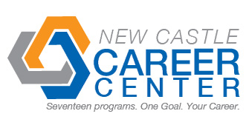
Student Profile
Name | Jarrod Lawson
Address | 2543 W Cr 100 S New Castle In, 47362
Cell Number | (765) 465-2190 |  | Email |  |  | Jarrodlawson1996@gmail.com
Career Program | Engineering
Certifications | Autodesk certified user---anticipated (spring 2014)
Dual Credits | 6 engineering, 6 more anticipated
Attendance: Days Missed This Year | 0 | Reason for Absences |  | n/a
Graduation Date | June 2014 | High School |  | Knightstown High School
Employment Interest | A CAD related summer internship or any part time work
Teacher Reference | Mr. Neal |  |  |  | Teacher Contact # |  | (765) 593-6680
Past Employers | Wendy’s
Able to Pass  Drug Test | yes
Employer Notes about the Student

